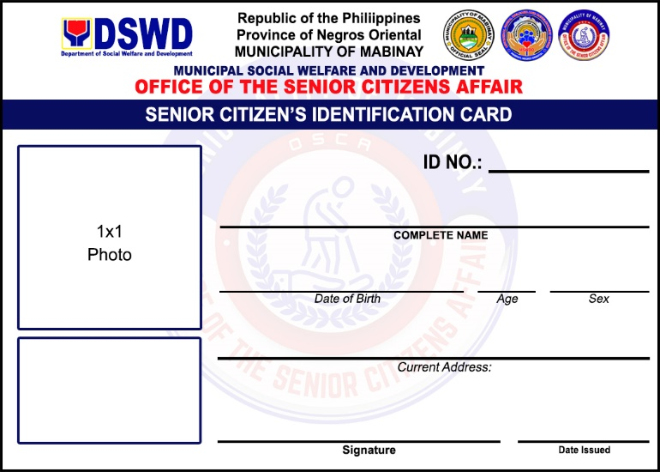
05781
ENRIQUETA AMPER DEGUIT
SEPTEMBER 09, 1952

74
FEMALE
BULWANG, Mabinay, Negros Oriental
Sept. 14, 2026
013503
JIMMY HABEDO ESTONANTO
MAY 31, 1963
63
MALE
BULWANG, Mabinay, Negros Oriental
Sept. 14, 2026

013883
JIMMY BALDOMAR ABUSO
NOVEMBER 03, 1961
65
MALE
BULWANG, Mabinay, Negros Oriental
Sept. 14, 2026
015985
ANICETO TALLEDO MISSION
APRIL 28, 1958
68
MALE
LUMBANGAN, Mabinay, Negros Oriental
Sept. 14, 2026
013408
EDGARDO LACORTE DEPALAS
DECEMBER 14, 1962
64
MALE
BULWANG, Mabinay, Negros Oriental
Sept. 14, 2026
015984
EDDIE BERTO CANDOL YBAÑEZ
FEBRUARY 24, 1959
67
MALE
LUMBANGAN, Mabinay, Negros Oriental
Sept. 14, 2026
011854
MIGUEL CADIVIDA SAPOS
SEPTEMBER 29, 1960
66
MALE
BULWANG, Mabinay, Negros Oriental
Sept. 14, 2026

012578
NELLIE ESTACION TEMBLOR
DECEMBER 11, 1962
64
FEMALE
LUMBANGAN, Mabinay, Negros Oriental
Sept. 14, 2026
013241
ERNESTO HERAMIS ANIÑON
SEPTEMBER 20, 1963
63
MALE
BULWANG, Mabinay, Negros Oriental
Sept. 14, 2026
08057
ROSINE TIJANO YBAÑEZ
MARCH 27, 1957
69
FEMALE
LUMBANGAN, Mabinay, Negros Oriental
Sept. 14, 2026
013444
LONGINO TEMBLOR ELECCION
MARCH 15, 1963
63
MALE
LUMBANGAN, Mabinay, Negros Oriental
Sept. 14, 2026

012999
ANTONIO ZERNA CADORNA
JUNE 07, 1962
64
MALE
TADLONG, Mabinay, Negros Oriental
Sept. 14, 2026

012469
MARIANITA PALOMAR ALLERA
DECEMBER 24, 1960
66
FEMALE
LUMBANGAN, Mabinay, Negros Oriental
Sept. 14, 2026

011017
LUCRECIO CAMBONGA ANDRADA
JUNE 30, 1961
65
MALE
TARA, Mabinay, Negros Oriental
Sept. 14, 2026

011320
LORNA B. ROSALEM
OCTOBER 02, 1960
66
FEMALE
LUMBANGAN, Mabinay, Negros Oriental
Sept. 14, 2026

02895
NORA GREGORIO DOMINGUEZ
MAY 05, 1949
77
FEMALE
AREBASORE, Mabinay, Negros Oriental
Sept .14, 2026

013358
TEOFILO GOMEZ ENARDICIDO
OCTOBER 12, 1950
76
MALE
ABIS, Mabinay, Negros Oriental
Sept. 14, 2026

013440
ELVIC TULBO SABANAL SR.
SEPTEMBER 24, 1963
63
MALE
LUMBANGAN, Mabinay, Negros Oriental
Sept. 14, 2026

014063
MACKENLEY CABUAL PALUMAR
NOVEMBER 13, 1961
65
MALE
LUMBANGAN, Mabinay, Negros Oriental
Sept. 14, 2026

014289
ENRICO GRAPA MARTIN
MARCH 23, 1963
63
MALE
BAGTIC, Mabinay, Negros Oriental
Sept. 14, 2026

012592
BLANDIE AMADO IÑOSA
SEPTEMBER 28, 1961
65
FEMALE
SAMAC, Mabinay, Negros Oriental
Sept. 14, 2026

011082
PACITA LIBATON CARA
MAY 09, 1956
70
FEMALE
LUYANG, Mabinay, Negros Oriental
Sept. 14, 2026

012381
NEMIA DELA PEÑA AMAHIT
NOVEMBER 08, 1962
64
FEMALE
SAMAC, Mabinay, Negros Oriental
Sept. 14, 2026

012139
TEODOLO ONAL QUIÑONES
JULY 26, 1961
65
MALE
LAMDAS, Mabinay, Negros Oriental
Sept. 14, 2026

011881
LEONITA MIÑOZA MALALAY
MARCH 23, 1961
65
MALE
TADLONG, Mabinay, Negros Oriental
Sept. 14, 2026

013191
MERLINDA YGOÑA VICADA
SEPTEMBER 08, 1963
63
FEMALE
CANGGOHOB, Mabinay, Negros Oriental
Sept. 14, 2026

014154
BASILISA QUIÑONES ABESTANO
APRIL 15, 1961
65
FEMALE
CANGGOHOB, Mabinay, Negros Oriental
Sept. 14, 2026

JULY 04, 1963
63
MALE
TADLONG, Mabinay, Negros Oriental
Sept. 14, 2026

MAY 11, 1961
65
MALE
TADLONG, Mabinay, Negros Oriental
Sept. 14, 2026

010803
ANGELINA DEMALI GUTANG
JULY 16, 1959
67
FEMALE
LUYANG, Mabinay, Negros Oriental
Sept. 14, 2026

